To go to Florence
You can follow the signs to get to the restaurant "La Beppa Fioraia", in Via Erta Canina, 6r, 50125 Florence
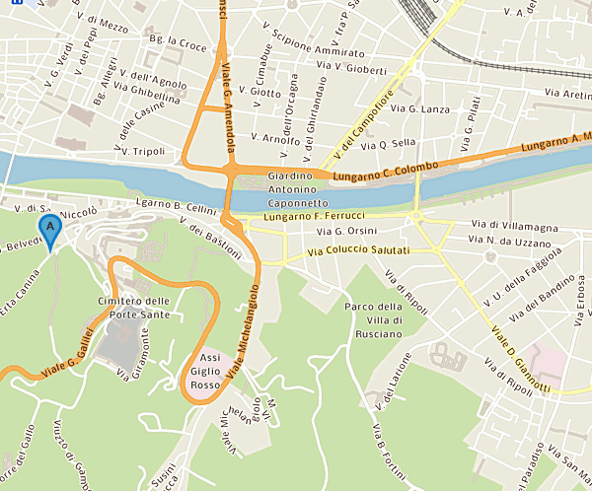

You come from Lungarno C. Colombo and you have to go in the direction of Piazzale Michelangelo.
Council:
Near where we suggest you park you can find a flight of steps leading to the Piazzale Michelangelo. The square is very famous for the wonderful view of Florence from the top and it's beautiful to see the sunset!
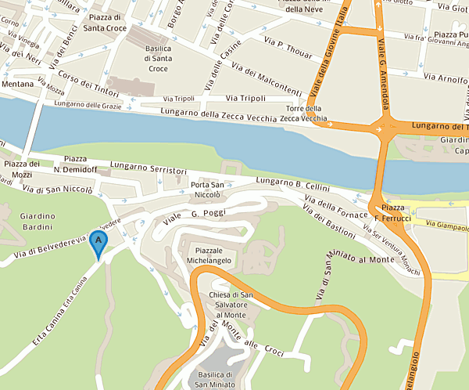
flight of steps

Once past the entrance you continue along the tree-lined street.
You can park anywhere. The road is long enough then definitely you will also find place on the busiest days

